CSC 472 Final Project Documentation

# Project title

Car Review App

# Is this a team project?

No

# Project description

This app will list customer reviews for most popular cars in the market. And it allows you to input reviews for a specific car.

* The app will classify cars by body types, i.e. Sedan, Hatchback, SUV.

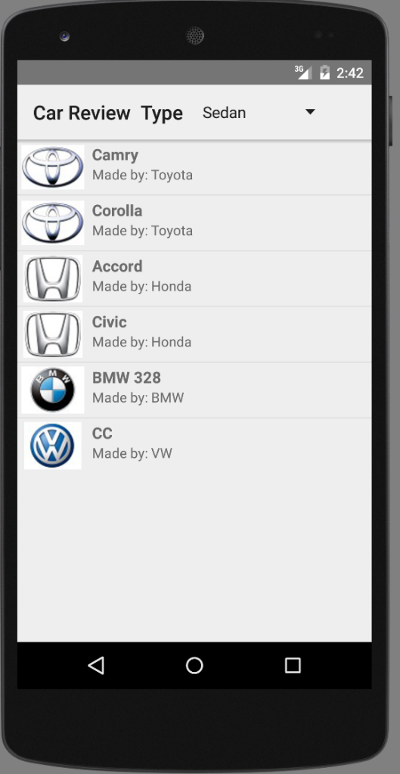

* The first activity list the cars in default body category, with a small logo picture. User can switch to different body categories by using Action Bar Spinner.

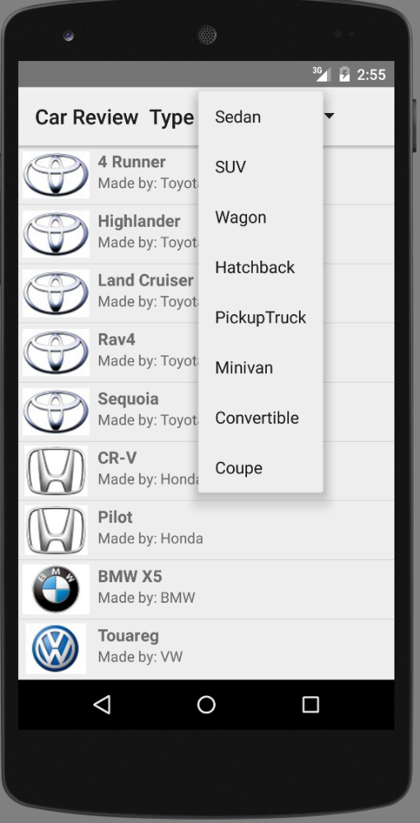

* When user turn the phone/tablet from portrait to landscape, the app will automatically change “Master/Detail” layouts which put body types at the left side while the car list at the right side.

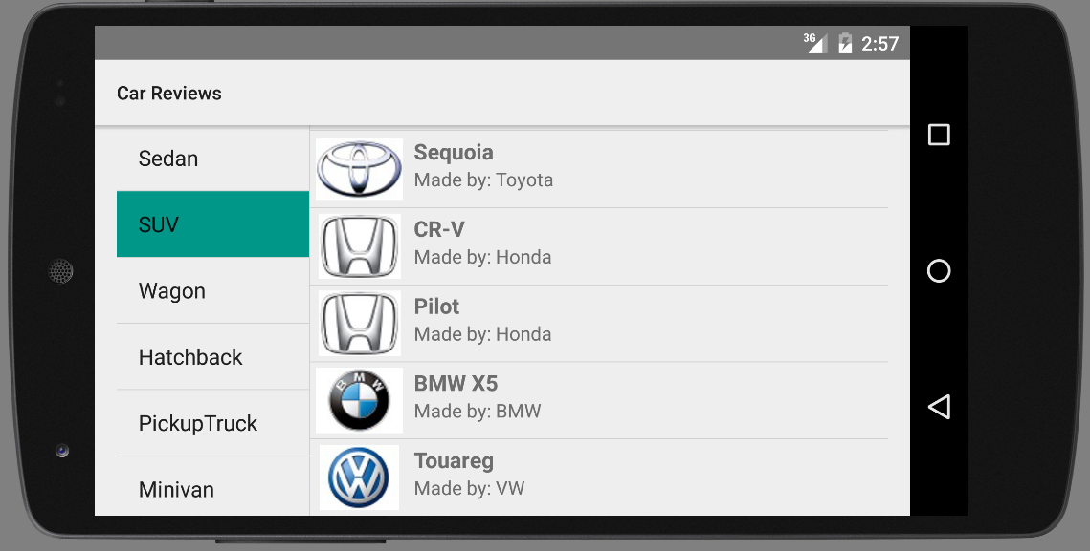

* When user click one of the car, the app will switch to a detail page for this car with bigger pictures; overall rating and customer reviews. The reviews listed in a scrollable page.

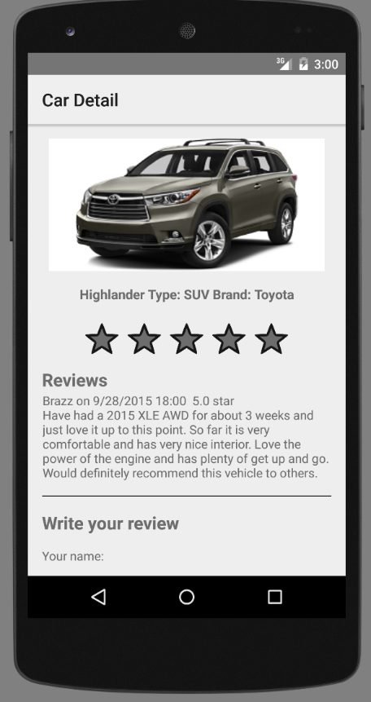

* Also the app allows you to input your review to a specific car.

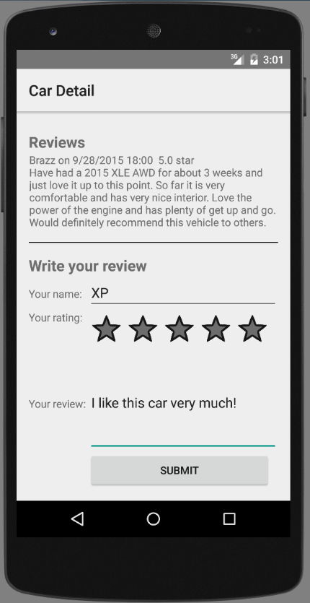

* All the customer reviews are saved in the shared preference for persistence.
* When you run the app, it will detect if the local data source was created. If not, it will initialize the data source using default data.

# Project technical explanation

* The project composed of
  + Two main Activities
    - MainActivity
    - CarDetailActivity
  + Two Fragments
    - TypeListFragment
    - CarListFragment
  + Three classes
    - Car
    - CarType
    - Review

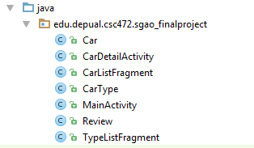

* The MainActivity is the LAUNCHER activity. It sets ContentView to R.layout.activity_main which have two different layouts for landscape and portrait orientations.



* Depends on different layouts, MainActivity will initialize Fragment(s), Action Bar Spinner and set corresponding ArrayAdapter for data and onSelectListener to handle user input.

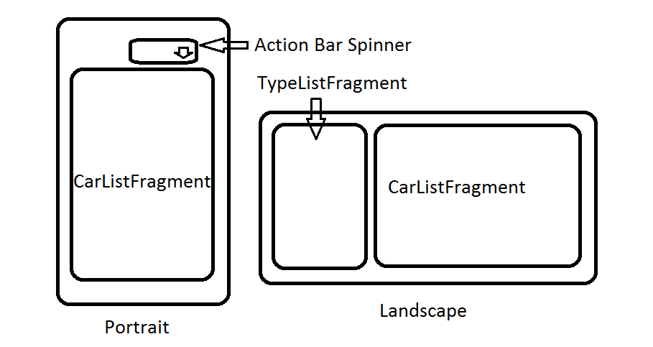

* It uses Publisher/Subscriber pattern to handle message communication between TypeListFragment and CarListFragment.
* The Car class defines all necessary information for a car. Also it contains a static array CARS which stores all the car information. It will be used to initialize the CarListFragment.

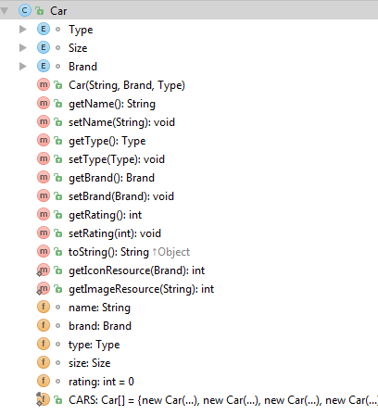

* The CarType class defines all necessary information for one type of car. Also it contains a static ArrayList ITEMS which stores all the car type information and a HashMap ITEM_MAP which maps a type string to a Type object. They will be used to initialize the Action Bar Spinner.

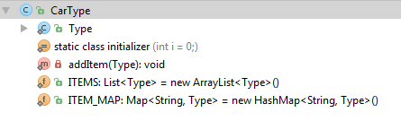

* The Review class defines all necessary information for a review. Also it contains a static HashMap REVIEWS which maps a car name to an ArrayList of Review objects. It will be used to store reviews in memory and generate the information on CarDetailActivity.

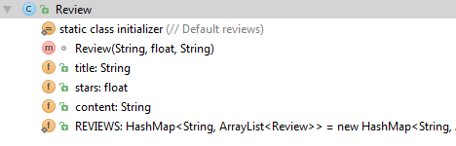

* When the app starts, it will detect if the local data source was created. If not, it will initialize the data source using default data.
* All the customer reviews are saved in the shared preference for persistence. After you exit the app and start it again, the previous reviews will be reloaded from shared preference.
* When user submit a new review, it will be stored both into the REVIEWS static HashMap and shared preference.
* The CarDetailActivity only read review data from the REVIEWS static HashMap for better performance. And it will calculate the overall rating dynamically based on all the individual ratings.